
ACCESSIBILITY

Microsoft Dynamics Snap
Business Data Lookup Snap-in
For Microsoft Dynamics™ AX 4.0 / 2007 Microsoft® Office system
Technical White Paper

February 16, 2007

Microsoft Dynamics Snap Sandbox

Table of Contents
EXECUTIVE SUMMARY 3
INTRODUCING MICROSOFT DYNAMICS SNAP 3
MICROSOFT DYNAMICS SNAP FOR BUSINESS DATA LOOKUP 3
FUNCTIONAL OVERVIEW 5
FIND THE BUSINESS DATA YOU NEED 5
BROWSE BUSINESS DATA 8
ATTACH OFFICE DOCUMENTS TO MICROSOFT DYNAMICS AX DATA 9
CUSTOMIZING ENTITIES AND RELATIONSHIPS TO SURFACE IN THE BUSINESS DATA LOOKUP SNAP-IN 10
HIGH LEVEL ARCHITECTURE 13
PRE-Requisites for using this Snap-in 15

EXECUTIVE SUMMARY
Many corporations implement business application systems like Microsoft Dynamics™ to automate their back-office business processes. Once those systems are in place, there are usually a select number of employees in the organization who are given access to them. However, the majority of information workers are not licensed to use these systems. Those employees tend to spend most of their time using the Microsoft Office® suite of applications to do their jobs. Although those workers could definitely benefit from access to relevant business data, they must either learn to do without--often using data that is outdated and no longer accurate, or they have to find someone with access to the system and get their help in order to get the information they need. What if there were ways to enable those information workers to access the data in Microsoft Dynamics applications from within Microsoft Office?

INTRODUCING MICROSOFT DYNAMICS SNAP
Microsoft Dynamics Snap applications do just that—they allow information workers to interact with Microsoft Dynamics business information, thereby increasing their productivity and enabling them to make decisions with confidence all from within the Microsoft Office applications they are most comfortable with and with which they are most familiar. Now all employees can get timely and accurate data out of or into the Microsoft Dynamics applications without ever having to leave Microsoft Office. Microsoft Dynamics Snap applications help companies maximize their investment in Microsoft technology by delivering the power of the Microsoft Dynamics business applications to every single employee.

MICROSOFT DYNAMICS SNAP FOR BUSINESS DATA LOOKUP
The Business Data Lookup Snap-in enables an Information Worker to look for information in Microsoft Dynamics AX™4.0 from within 2007 Microsoft® Office system applications. Using a task pane launched within Word, within Microsoft Excel® or within an email in Microsoft Outlook®, the Information Worker can
- Search for records like customers, contacts, sales orders, inventory items etc.
- View details of these records
- Browse data related to a particular record, e.g. all sales orders for a particular customer
- Select and copy data into the document
- Attach the document to a selected record in Microsoft Dynamics AX for reference
Surfacing the data from Microsoft Dynamics AX 4.0 in the Office environment has many benefits. It helps:
- Minimize costly duplication of effort and errors in data entry
- Create a streamlined user experience, increasing productivity by eliminating the need to switch programs or interrupt someone else’s workday to get access to information
- Decrease training costs as the Microsoft Dynamics Snap applications are very simple and intuitive to use
- Improve decision making by providing access to real-time data

Phase 1 and 1.5 releases of the Business Data Lookup Snap-in worked with Microsoft Dynamics AX 3.0 and Microsoft Office 2003 and were distributed under the Microsoft Permissive License at the Dynamics Snap site on GotDotNet.com. Microsoft partners and customers are encouraged to extend and customize these applications as well as to use their components within applications they have developed. The Phase 2 release has been upgraded to work with Microsoft Dynamics AX 4.0 and the 2007 Microsoft Office system.
This white paper is divided into two sections, the first to help you understand the features of the Business Data Lookup snap-in and the second to help you use the technology to customize your own solutions:
- Functional overview: This section explains the Business Data Lookup Snap-in functionality.
- High level architecture and customization: This section explains the various technologies used and how they work together to provide the functionality. Partners may use a similar framework to build additional scenarios.

FUNCTIONAL OVERVIEW
Most business users spend a large part of their time working in the Microsoft Office environment. Yet, completing simple and frequent tasks like browsing business data, inserting business information into documents, and attaching documents to Microsoft Dynamics AX data can be quite difficult to do often requiring them to interrupt someone else’s workday to get timely and accurate information. This decreases productivity while increasing the chance that the data that gets used is out of date, or incomplete.
The Business Data Lookup Snap-in allows business workers to search and browse Microsoft Dynamics AX data from within the Microsoft Office environment (Word, Excel or Outlook) using the Microsoft Office task pane. They can also copy data into Microsoft Office documents and attach Microsoft Word or Microsoft Excel documents to Microsoft Dynamics AX records.
The next few screenshots demonstrate how easy it can be for users to view and insert this data from Microsoft Dynamics AX while working in the familiar Microsoft Office environment. As an example, consider a scenario where you need to provide one of your customers with the status update of his orders.

FIND THE BUSINESS DATA YOU NEED
In a Word document, an Excel spreadsheet, or while composing an Outlook e-mail message, all you need to do is click Insert From AX button in the BDL – AX 4.0 section under the Snap tab of the ribbon to launch the Business Data Lookup - AX task pane. This allows you to browse Microsoft Dynamics AX data by choosing the entities you wish to search in the Look In field, typing the text you wish to search for in the Look For field, then clicking the Search button, , on the task pane. In the scenario mentioned above, to get information regarding the customer, you will select customer as the entity and enter first few characters of his name in the Look For field. 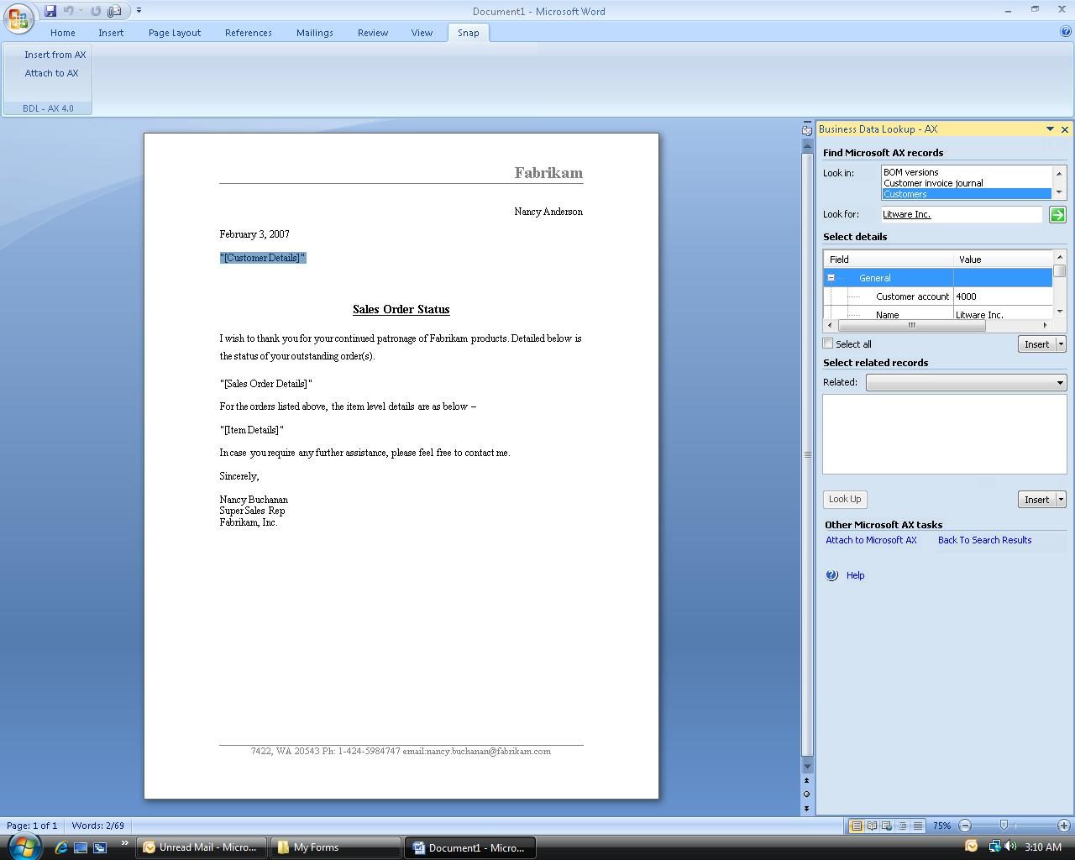
You can also right-click any word or phrase in a Microsoft Word or Microsoft Excel document and search for it in Microsoft Dynamics AX using the context sensitive Search in AX menu item. This menu item invokes the Business Data Lookup task-pane with the Look For field filled with the selected text. The search results are displayed in the Record Details section of the task pane, grouped by entity names.
View record details
To view the details of the records returned by search, double click the record. This opens the record in the detailed view with all the fields shown. In the case of the customer record you searched for, the detailed information will show the fields of a customer record from Microsoft Dynamics AX, like address, phone, contact person, etc.
Copy data into the Document
You can copy data shown in the task pane to your Microsoft Office document. To do this, select the fields you wish to insert into the document from the Select Details section and click Insert. The selected records will be copied to your Office document as simple text. You can also insert data as a table by choosing Insert as table option of the Insert split button. In the scenario mentioned above, if you are composing a document with the status information, you can insert the address details of the selected customer into the document by selecting the data and clicking insert.
View and insert data of related records
To look for and insert data pertaining to records that are related to the record you selected, find the relation you wish to explore from the Related drop down and then select one or more records from the list of related records on the Business Data Lookup - AX task pane and insert the fields that you want to add into the document. This will help you look up all sales orders of the customer by selecting ‘Sales Orders’ in the Related drop down and in a single click, insert the neatly formatted details into the document. 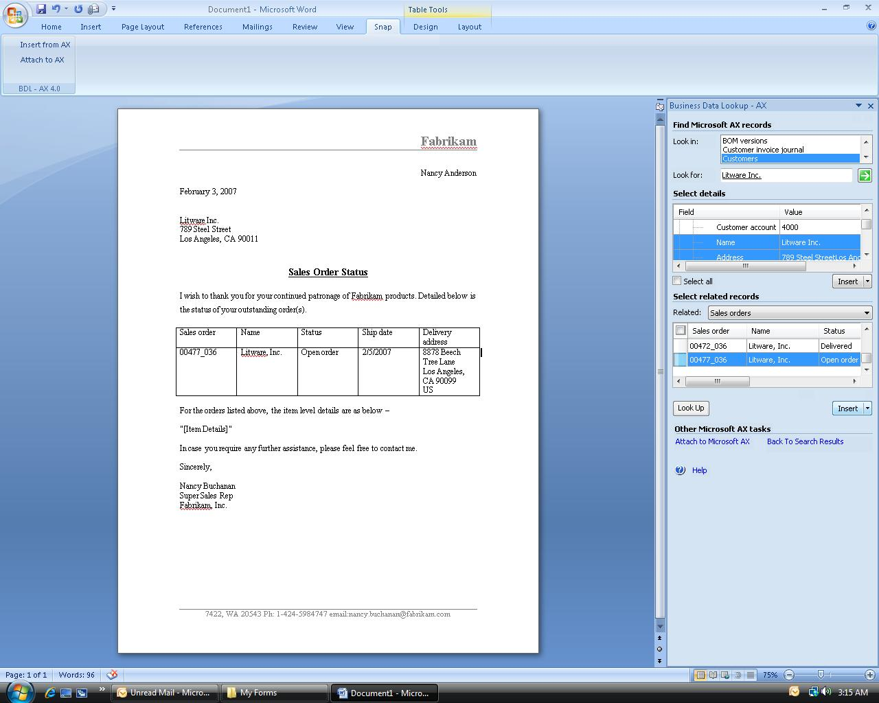

BROWSE BUSINESS DATA
You can browse the hierarchy of related entities by promoting the related record as the primary record and then viewing its details or other entities related to it in the same task pane. To do so, select a related record and click Look Up. The selected related record will become the top level entity and the details and related records that appear will pertain to the newly promoted entity. This will allow you to add further details about the orders you are informing the customer about. For example, you can promote the open sales order as primary entity and then insert details about the items comprising the sales order by selecting Item Details in the Related drop down.

ATTACH OFFICE DOCUMENTS TO MICROSOFT DYNAMICS AX DATA
You can attach documents to a Microsoft Dynamics AX record without leaving the Microsoft Word or Microsoft Excel document that you are working in (this option is not available in Outlook). To do this, while you are in Word or Excel, click on the Attach to AX button on the Ribbon to bring up the Business Data Lookup – AX task pane. If the task pane is already visible you may click on the Attach to AX link that is provided under the Other Microsoft Dynamics AX tasks section. Browse to the 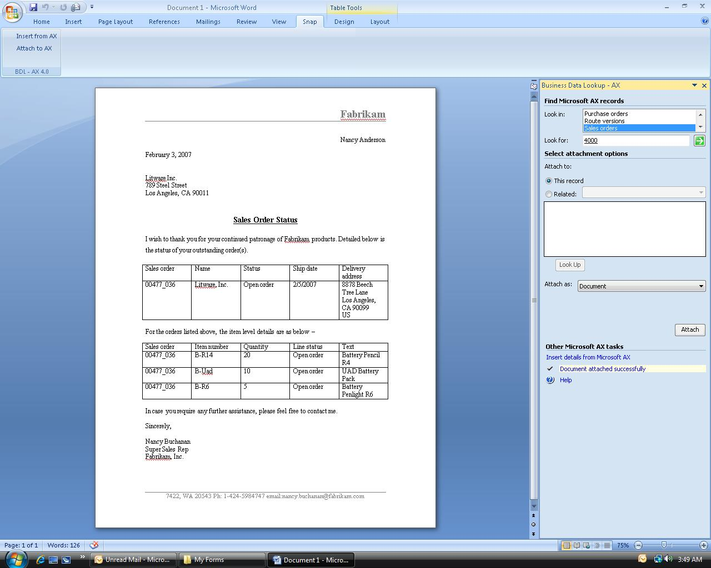record of your choice, choose the record to attach document to, and click Attach. The document will be attached to the Microsoft Dynamics AX 4.0 record. Additionally you can specify the attachment type before attaching the document. These attachment types are pre-fetched from Microsoft Dynamics AX.

CUSTOMIZING ENTITIES AND RELATIONSHIPS TO SURFACE IN THE BUSINESS DATA LOOKUP SNAP-IN
The Business Data Lookup snap-in runs from an XML configuration file and is customizable by making changes to that configuration file. Following are the configuration parameters in the Business Data Lookup snap-in that are driven from the configuration file:
- List of entities that can be searched and the corresponding tables in Microsoft Dynamics AX to which the entities map
- List of fields to search in, for each entity
- List of field groups to show in results when an entity is a primary entity (primary entity is one whose details are visible in Select Details table in the task pane)
- List of field groups to show in results when the entity is shown as a related entity
The default XML configuration file that is shipped with the application can be changed by the administrator or system integrator and it should reside on the local machine. Described below is a sample configuration file with an explanation of each tag. You may use this as a reference while you customize the Business Data Snap-in for your use.

<?xml version="1.0" encoding="utf-8"?>
<Configuration>
<SystemConfiguration>
</SystemConfiguration >
<EntityConfiguration>
<Entity Name = "Customer" Table = "CustTable" TableId = "77" MainEntity ="Yes">
<Groups>
<Group DisplayName ="General" AxName="AutoReport"></Group>
<Group DisplayName ="Description" AxName="Description"> </Group>
<Group DisplayName ="Invoice" AxName="Invoice"></Group>
</Groups>

<QuickSearch>
<Attribute Name ="AccountNum"/>
<Attribute Name ="Name"/>
</QuickSearch>

<RelatedView>
<Attribute Name ="AccountNum"/>
<Attribute Name ="Name"/>
<Attribute Name="NameAlias"/>
<Attribute Name="InvoiceAccount"/>
<Attribute Name ="CustGroup"/>
<Attribute Name="Currency"/>
</RelatedView>
<ParentTo>
<ChildEntity Name = "ContactInfo">
<RelationInfo ParentAttrName ="Accountnum" ChildAttrName ="CustAccount"/>
</ChildEntity>
</ParentTo>
</Entity>

<Entity Name = "ContactInfo" Table ="ContactPerson" TableId = "520">
<Groups>
<Group DisplayName ="General" AxName="AutoReport"> </Group>
<Group DisplayName ="ContactInfo" AxName="ContactInfo"></Group>
<Group DisplayName ="Identification" AxName="Identification"></Group>
<Group DisplayName ="NameDetails" AxName="NameDetails"></Group>
<Group DisplayName ="OverView" AxName="Overview"></Group>
<Group DisplayName ="PersonalDetails" AxName="PersonalDetails"></Group>
<Group DisplayName ="Title" AxName="Title"></Group>
</Groups>

<QuickSearch>
<Attribute Name ="Name"/>
<Attribute Name="CustAccount"/>
</QuickSearch>

<RelatedView>
<Attribute Name ="Name"/>
<Attribute Name ="Phone"/>
<Attribute Name="Email"/>
<Attribute Name="CustAccount"/>
<Attribute Name="Title"/>

</RelatedView>
<ParentTo>
</ParentTo>
</Entity>
</EntityConfiguration>
</Configuration>

Notes on tags
Tag | Description
Entity Name | Describes the name to show to the user for the respective Microsoft Dynamics AX entity as defined by EntityTable.
Entity Table | The respective Microsoft Dynamics AX table the entity refers to.
Entity TableId | Uniquely identifies the Microsoft Dynamics AX application object to be used.
Entity MainEntity | Indicates whether the entity is visible as a top level searchable entity (in the Look in drop-down list) or only a related entity (available in "Search for Related Records").
Groups | Field groups in Microsoft Dynamics AX to display in the Details pane when a record is found.
QuickSearch | Fields in a Microsoft Dynamics AX table to search on for the text entered in the "Look For" field.  Example: In the Customer entity shown in the preceding configuration example, the AccountNum and Name fields are used to search for records.
RelatedView | Lists the attributes to show when this entity is chosen in related record view.
ParentTo | Describes which entities to show in the related records view when this entity is the top level entity.  Note – Related entities must be defined by using an Entity tag.
ChildEntity | Describes the Child Entity that has the current entity as a parent.
RelationInfo | Defines the parent and child for each relation.
ParentAttrName | Parent entity name
ChildAttrName | Child entity name

HIGH LEVEL ARCHITECTURE
The Business Data Lookup Snap-in uses Microsoft Visual Studio® 2005 Tools for Office Second Edition (VSTO SE) system. The VSTO system includes projects for two main types of solutions. Microsoft Office Word 2007 and Microsoft Office Excel 2007 projects can be used to build document-level solutions, in which a managed code assembly is attached to a Word document or Excel workbook as an Add-in. Microsoft Outlook projects can be used to build application-level solutions, in which a managed code assembly runs as an add-in within Outlook.
Software Requirements for Running the Application
- Microsoft Outlook 2007
- Microsoft Word 2007
- Microsoft Excel 2007
- Microsoft Dynamics AX 4.0 .NET Business Connector
- Microsoft .NET 2.0 - Runtime
- Microsoft Visual Studio 2005 Tools for Office Runtime - SE
The diagram below depicts the high level architecture for this snap-in:

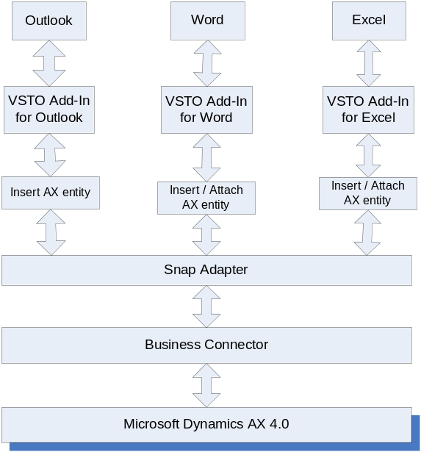

After you install the VSTO 2005 SE runtime and run the Business Data Lookup Snap-in setup, it creates the required DLLs, application manifests and registry entries that allow the target Microsoft Office application (Microsoft Office Word 2007/Microsoft Office Excel 2007/Microsoft Office Outlook 2007) to recognize this application as a valid COM add-in and load it during the startup of these Microsoft Office applications. While loading, the add-in creates the required context menus and ribbon items. When the user opts to use the Business Data Lookup Snap-in to insert or attach Microsoft Dynamics AX entities via the Snap ribbon tab or through the context menu, the add-in initializes and creates a fresh custom task pane and a Snap Adapter connection to the Microsoft Dynamics AX server specified during setup. The snap adapter layer provides the interface to conveniently access the back end data and surface it at the custom task pane via the Microsoft Dynamics AX .NET Business connector DLL. The custom task pane uses the object model of the calling application to interact with the open Microsoft Office document, to insert data from the Microsoft Dynamics AX record or to attach the document to it.

PRE-Requisites for using this Snap-in
- Microsoft Office 2007 should be installed, along with all the latest updates, and Microsoft Outlook should have been run at least once on the local machine
- Microsoft Dynamics AX 4.0 SP4 client and .NET Business Connector 4.0 should be installed on the local machine with an active configuration that can access the Microsoft Dynamics AX 4.0 Server
- The user must have permissions and access to the Microsoft Dynamics AX 4.0 server
- Microsoft .NET Framework 2.0 should be installed on the system
- Microsoft VSTO 2005 SE Runtime should be installed on the system

For more details on the pre-requisites and configuration requirements, please refer the installation guide in the setup package.

The information contained in this document represents the current view of Microsoft Corporation on the issues discussed as of the date of publication. Because Microsoft must respond to changing market conditions, this document should not be interpreted to be a commitment on the part of Microsoft, and Microsoft cannot guarantee the accuracy of any information presented after the date of publication.
This White Paper is for informational purposes only. MICROSOFT MAKES NO WARRANTIES, EXPRESS, IMPLIED, OR STATUTORY, AS TO THE INFORMATION IN THIS DOCUMENT.
Complying with all applicable copyright laws is the responsibility of the user. Without limiting the rights under copyright, no part of this document may be reproduced, stored in or introduced into a retrieval system, or transmitted in any form or by any means (electronic, mechanical, photocopying, recording, or otherwise), or for any purpose, without the express written permission of Microsoft Corporation.
Microsoft may have patents, patent applications, trademarks, copyrights, or other intellectual property rights covering subject matter in this document. Except as expressly provided in any written license agreement from Microsoft, the furnishing of this document does not give you any license to these patents, trademarks, copyrights, or other intellectual property.

© 2006 Microsoft Corporation. All rights reserved.
Microsoft, the Microsoft Dynamics Logo, 2007 Microsoft Office System, BizTalk, Dexterity, FRx, Microsoft Dynamics, SharePoint, Visual Basic, Visual C++, Visual SourceSafe, Visual Studio, Windows, and Windows Server are either registered trademarks or trademarks of Microsoft Corporation, FRx Software Corporation, or Microsoft Business Solutions ApS in the United States and/or other countries. Microsoft Business Solutions ApS and FRx Software Corporation are subsidiaries of Microsoft Corporation.
Microsoft Dynamics is a line of integrated, adaptable business management solutions that enables you and your people to make business decisions with greater confidence. Microsoft Dynamics works like and with familiar Microsoft software, automating and streamlining financial, customer relationship and supply chain processes in a way that helps you drive business success.

www.microsoft.com/dynamics

